23CSE111

OBJECT ORIENTED PROGRAMMING

LAB MANUAL


Department of Computer Science and Engineering Amrita School of Computing
Amrita Vishwa Vidyapeetham, Amaravati Campus

Verified by: NAME: M. NIKHIL SAI
ROLLNO: AV.SC.U4CSE24211

S.No. | Experiment Name | Page No. | Remarks | Signature
 | WEEK-1
1 | Installation Process of JDK
2 | Simple Java Program for printing basic details of student
 | WEEK-2
1 | Write a Java Program for finding simple interest by taking input from User
2 | Write a simple program to calculate factorial of a number and read the input from user
3 | Write a program to to calculate the fibonacii sequence and take the input from user
4 | Write a java program to convert temperature from Fahrenheit to celsius
5 | Write a java program to convert temperature from Celsius to Fahrenheit
6 | WRITE A JAVA PROGRAM TO FIND THE AREA OF A RECTANGLE
7 | WRITE A JAVA PROGRAM TO FIND THE AREA OF A TRIANGLE
 | WEEK-3
1 | To create java program with following instructions  1.Create a class with name car  2. Create four attributes named car colour ,Car brand, fuel type, mileage  3. Create three methods named start(), stop(). Service()  4. Create three objects named car1, car2 and car3
2 | WRITE A JAVA CLASS FOR A BANK ACCOUNT WITH DEPOSIT() AND WITHDRAW() AS METHODS.
 | WEEK-4
1 | WRITE A JAVA PROGRAM WITH CLASS NAMED “Book”. THE CLASS SHOUKD CONTAIN VARIOUS ATTRIBUTES SUCH AS TITLE, AUTHOR, YEAR OF PUBLICATION. IT SHOULD ALSO CONTAIN A CONSTRUCTOR WITH PARAMETERS WHICH INITIALIZES TITLE, AUTHOR, YEAR OF PUBLICATION AND CREATE A METHOD WHICH DISPLAYS THE DETAILS OF 2 BOOKS.
2 | WRITE A JAVA PROGRAM WITH CLASS NAMED “MyClass” WITH A STATIC VARIABLE COUNT OF INT TYPE. INTIALIZE IT TO ZERO AND A CONSTANT VARIABLE “Pi” OF TYPE DOUBLE INITIALIZED TO “3.14” AS ATTRIBUTES OF THAT CLASS. NOW DEFINE A CONSTRUCTOR FOR “MyClass”, THAT INCREMENTS THE COUNT VARIABLE EACH TIME AN OBJECT OF “MyClass” IS CREATED. FINALLY, PRINT THE FINAL VALUES OF ‘COUNT’ AND ‘PI’ VARIABLES AND CREATE 3 OBJECTS.
 | WEEK-5
1 | Create a calculator using the operations including addition, subtraction, multiplication,  and division using multilevel inheritance and display the desired output.
2 | A vehicle rental company wants to devlop a system that maintains information about different types of vehicles available for rent. The company rents out cars , bikes and trucks and they need a program to store details about each vehicle, such as brand and speed
 | WEEK-6
1 | Write a java program to create a Vehicle class with a method displayInfo().Override this method in the car subclass to provide specific information about a car.
2 | A college is developing an automated admission system that verifies student’s eligibility for Undergraduate(UG) and Postgraduate(PG) programs. Each program has different eligibility criteria based on the student’s percentage in their previous qualification.
3 | Create a calculator class with overloaded methods to perform addition:  1.add two integers  2.add 2 doubles  3.add 3 integers
4 | Create a shape class with a method “calculateArea()” that is overloaded for different shapes(ex:square,rectangle,triangle).then create a subclass “Circle” that overrides the calcArea() method for a circle.
 | WEEK-7
1 | Write a java program to create an abstract class Animal with an abstract method called sound().Create subclass lion and tiger that extend the animal class and implement extend the Animal class and implement the sound() method to make a specific sound for each animal.
2 | Write a java program to create an abstract class Shape3D with abstract methods calculateVolume() and calculateSurfaceArea().Create subclasses sphere and cube that extend the Shape3d class and implement the respective methods to calculate volume and surface area of each shape.
3 | Write a java program using an abstract class to define a method for printing patterns.  -Create an abstract class named PatternPrinted with an abstract method print pattern(int n) and a create a method to display the patterntitle.  -Implement two subclasses:  1. star pattern-right angled.  2.numberpatterns-prints a right-angled triangle of increasing numbers.
 | WEEK-8
1 | Write a java program to create an interface Shape with the getPerimeter() method. Create three classes Rectangle, circle and triangle that implements the shape interface. Implement the gerPerimeter() method for each of the three classes.
2 | Write a java program to create an interface Playable with a method play() that takes no arguments and returns void. Create three classes Football,Volleyball and Basketball that implement the Playable interface and override the play() method to play the respective sports.
 | WEEK-9
1 | Write a java program to create a method that takes integer as parameter and throws an Exception if the number is even.
2 | Write a java program to create a method that reads a file and throws an Exception if the file is not found.
3 | Write a java program to handle Arithmetic Exception using try, catch and finally.
4 | Write a java program to simulate a University system using Inner classes.  Create an outer class named University with a variable universityName. Inside it, define two non-static inner classes.  1.Department-with variables like deptName and deptCode and a method to display department details.  2.Student-with variables like studentName and rollNumber and a method to display student details.  3.Create a method for each class and call their methods to display their details along with the university name.
 | WEEK-10
1 | Write a java program to generate a password for a student using his/her initials and age. the password displayed should be the string consists of first character of first name, middle name, last name with age.
2 | Design and implement a Java program that will do the following operations to this string "Welcome! You are practicing strings concept."  a. convert all alphabets to capital letters and print out the result.  b. convert all alphabets to lower-case letters and print out the result.  c. print out the length of the string.  d. print out the index of Course.
3 | Implement a java program using the below array methods.  a. Sorting the elements (numbers and Strings) of an array.  b. convert the array elements into string.  c. fill the part of an array.  d. copy the elements of one array into another.
4 | Implement a java program using the below Array List methods.  a. insert an element at particular index in the array list.  b. Modify an element in the array list.  c. Access an element from the array list.  d. Remove an element from the array list.  e. clear the elements from the array list.

WEEK-1
AIM: How to download and install java software in your computer.
1.Steps for downloading.
Step 1: Java is developed by oracle. so open your web browser and search for java oracle.
Step 2: Then go to the website https://www.oracle.com/in/java/ .
Step 3: And navigate to the java downloads. Then some earlier versions are available like
- JDK 23
- JDK 21
- GraalVM for JDK 23
- GraalVM for JDK 21
Step 3: JDK 21 is the latest Long-Term Support (LTS) release of the Java SE Platform. So we use this version.
Step 4: According to your device operating system choose the product/file description.
Step 5: Then the version will be automatically downloaded.
2.Steps for installation.
Step 1: Go to the folder where it was downloaded.
Step 2: Then open and accept all terms and conditions.
Step 3: And install it.

3.Setting environmental variables.
Step 1: Open file explorer, then right click on This PC next select on properties then it will take you to the settings app then click on advanced system settings and then click on Environment Variables.
Step 2: Click New under System Variables:
    - Set Variable name as: java_home
    - Variable value: The folder address where JDK is installed (like C:\Program Files\Java\jdk-21\bin)
Step 3: Find Path under System Variables, click Edit, and add the path of the jdk-21(D:\UNI+\EDU\JAVA)

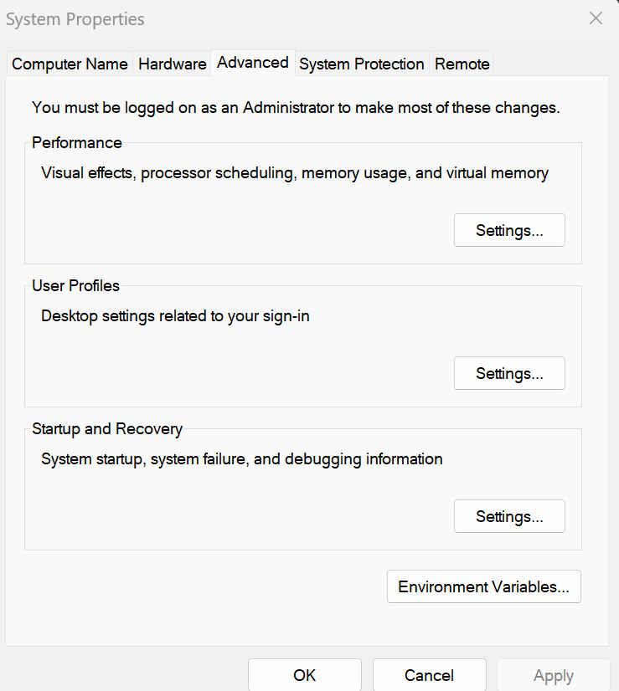

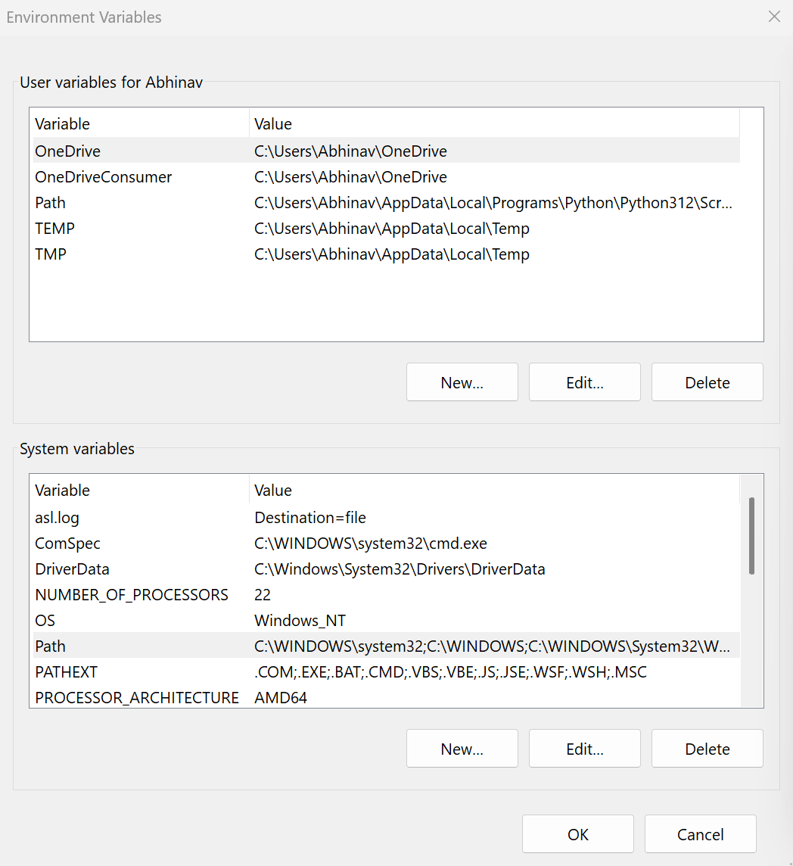
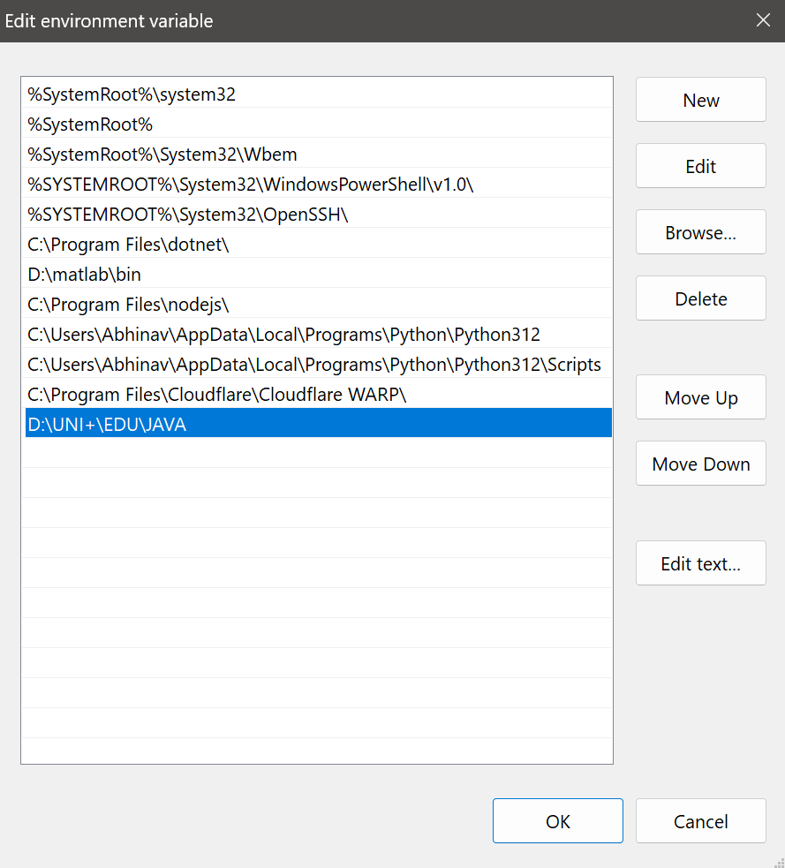

4.Checking for jdk(java development kit) version.
Step 1: Open command promt.
Step 2: Enter javac --version for version of jdk installed.
Step 3: Enter java –version for all details like when downloaded and path of environment variables
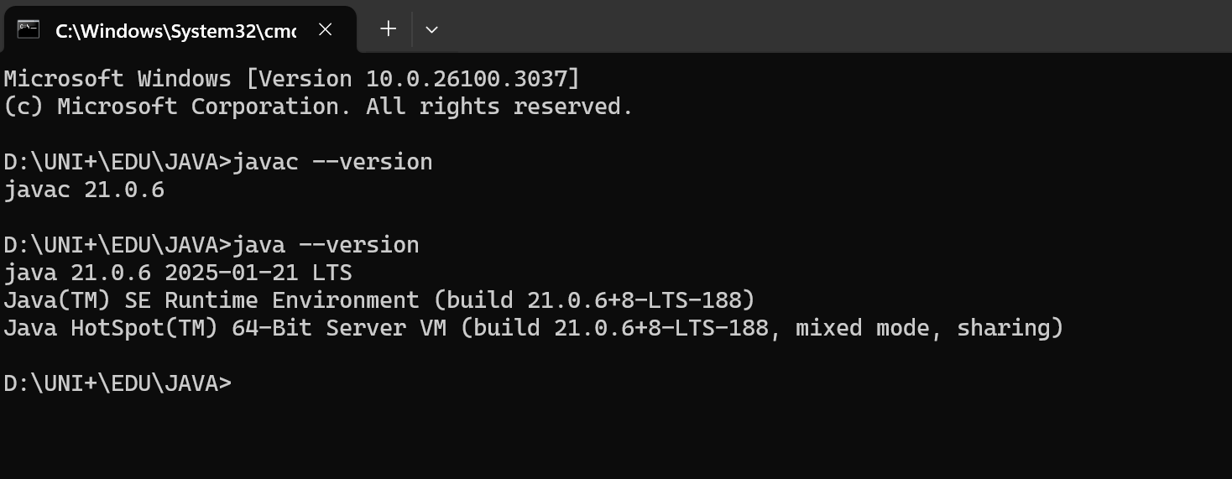
1)AIM-Write a java program to print student’s Name, Roll Number, Branch.
Program :
Positive case:
class Demo
{
public static void main(String[ ] args)

{
System.out.println("NAME= M.NIKHIL SAI");
System.out.println("ROLL NO= AV.SC.U4CSE24211");
System.out.println("SEC= C");
System.out.println("BRANCH= CSE");
}
}

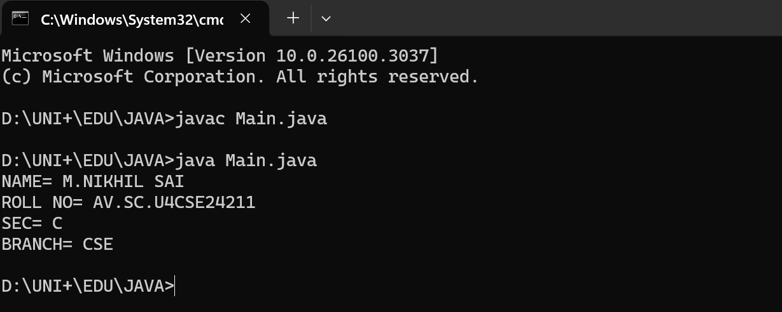
Negative Case:
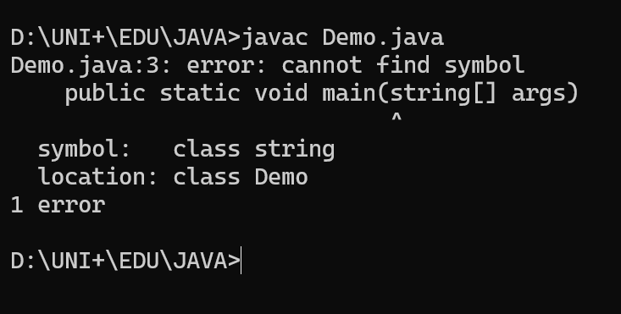
Errors:

S.NO | Error Name | Error Rectification
1 | Syntax/ Compilation Error | Absence of Semicolon
2 | Closing Brackets | Need to Close the brackets
3 | Wrong syntax in string | Rectified by changing the String

WEEK-2
1)AIM-Write a Java Program for finding simple interest by taking input from User
Program:
Positive case:
import java.util.*;
class simple{
public static void main(String args[]){

float SI;
Scanner sc=new Scanner(System.in);
System.out.println("Enter principle value:");
int P = sc.nextInt();
System.out.println("Enter time:");
int T = sc.nextInt();
System.out.println("Enter rate of interest:");
float R= sc.nextFloat();
SI=(P*T*R)/100;
System.out.println("Simple interest is:"+SI);
}
}

OUTPUT:
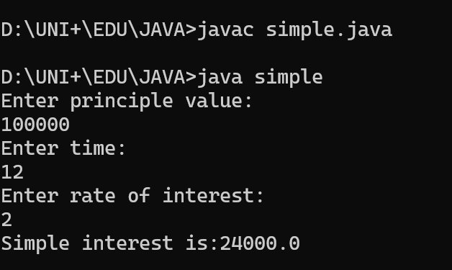

Negative case:
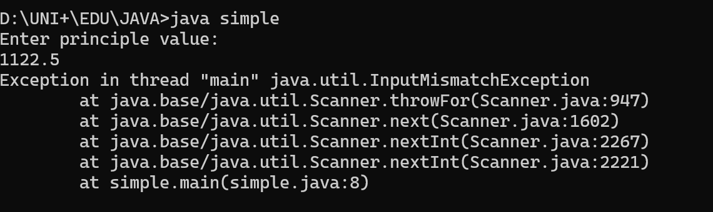
=>When we give input in decimal form for principle value it will show error.
=>It cant compile the code and cant show the output.
S.No | Error type | Reason for error | rectification
1 | Runtime error | Incorrect path | Copied correct path
2 | Syntax error | { missing | { added
3 | Logical error | Wrong formula | Formula rectified
ERROR TABLE:

IMPORTANT POINTS:
=>We have used scanner method to give input to the code
=>Formula of the simple interest is (P*T*R)/100
=>We have assigned values for P,T,R

2)AIM-Write a simple program to calculate factorial of a number and read the input from user
Program:
Positive case:
import java.util.Scanner;

public class factorial {
public static void main(String[] args) {
Scanner scanner = new Scanner(System.in);
System.out.print("Enter a number: ");
int number = scanner.nextInt();
int result = factorial(number);
System.out.println("Factorial of " + number + " is: " + result);
scanner.close();
}

public static int factorial(int n) {
if (n == 0) {
return 1;
} else {
return n * factorial(n - 1);
}
}
}

OUTPUT:
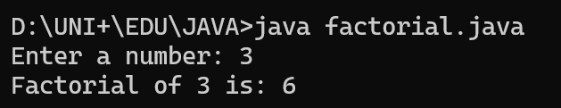
Negative case:
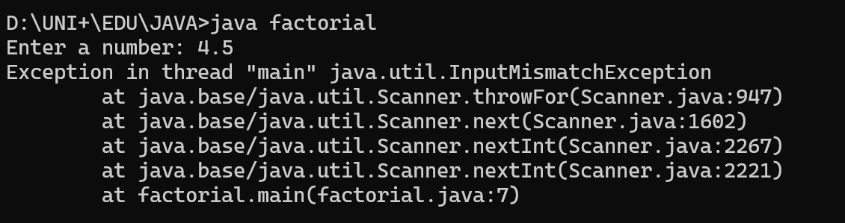
=>When we give input in decimal form for principle value it will show error.
=>It cant compile the code and cant show the output.
S.No | Error type | Reason for error | Rectification
1 | Undeclared variable error | Missing variable | Variable declared
2 | Missing import statement | Not importing packages | Packages imported
3 | Logical error | Wrong formula | Formula rectified
ERROR TABLE:

IMPORTANT POINTS:
- Importing Scanner:
  - The code imports the Scanner class from the java.util package to read user input.
- Main Method:
  - The main method is the entry point of the program. It creates a Scanner object to read user input and prompts the user to enter a number.
- Factorial Calculation: The factorial method is defined as a static method that takes an integer n and returns the factorial of n.
  - method uses recursion to calculate the factorial. If n is 0, it returns 1 (base case). Otherwise, it returns n * factorial(n - 1).
- Closing Scanner:
  - The scanner.close() method is called to close the Scanner object and release the resources associated with it.
- Recursion:
  - The use of recursion in the factorial method is a key point. It repeatedly calls itself with decremented values of n until it reaches the base case.
3)AIM-Write a program to to calculate the fibonacii sequence and take the input from user
Program:
Positive case:
import java.util.*;
class fibo
{
public static void main(String args[])
{
Scanner sc = new Scanner(System.in);
int num;
int f3;
int f1 = 0;
int f2 = 1;
int i = 2;

System.out.print("Enter a number:");
num = sc.nextInt();
System.out.println(f1);
System.out.println(f2);

while(i<num)
{
f3 = f1+f2;
f1 = f2;
f2 = f3;
System.out.println(f3);
i = i+1;
}
}
}
Output:
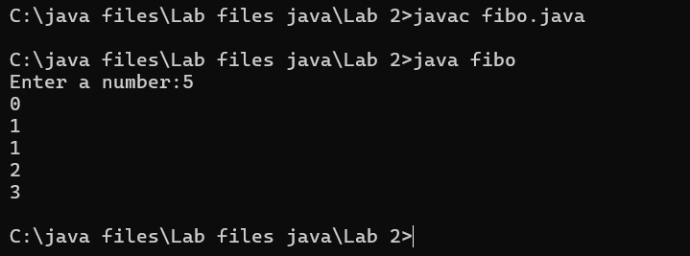
Negative case:
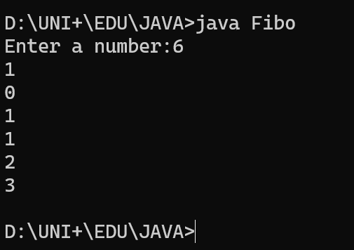

=>I have rearranged the starting two elements from 0 and 1 to 1 and 0.
=>Therefore, the order of Fibonacci series is changed.
ERROR TABLE:

S.No | Error type | Reason for error | Rectification
1 | Logical error | Incorrect formula | Formula rectified
2 | Run-time error | Incorrect path | Added correct path
IMPORTANT POINTS:
=> Importing Scanner:
- The code imports the Scanner class from the java.util package to read user input.
=> Class Declaration:
- The code declares a class named fibo.
=> Main Method:
- The main method is the entry point of the program. It creates a Scanner object to read user input and prompts the user to enter a number.
=> Variable Initialization:
- The code initializes variables:
  - num: The number of Fibonacci terms to be generated.
  - f3: Used to store the next Fibonacci term.
  - f1 and f2: The first two terms of the Fibonacci sequence, initialized to 0 and 1, respectively.
  - i: Counter variable initialized to 2 since the first two terms are already known.

4)AIM-Write a java program to convert temperature from Fahrenheit to celsius
Program:
Positive case:
import java.util.Scanner;

public class FahrenheitToCelsius {
public static void main(String[] args) {
Scanner scanner = new Scanner(System.in);
System.out.print("Enter temperature in Fahrenheit: ");
double fahrenheit = scanner.nextDouble();
double celsius = fahrenheitToCelsius(fahrenheit);
System.out.println("Temperature in Celsius: " + celsius);
scanner.close();
}

public static double fahrenheitToCelsius(double fahrenheit) {
return (fahrenheit - 32) * 5/9;
}
}

Output:
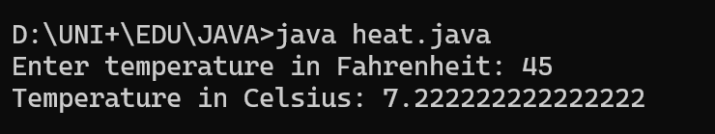

Negative case:
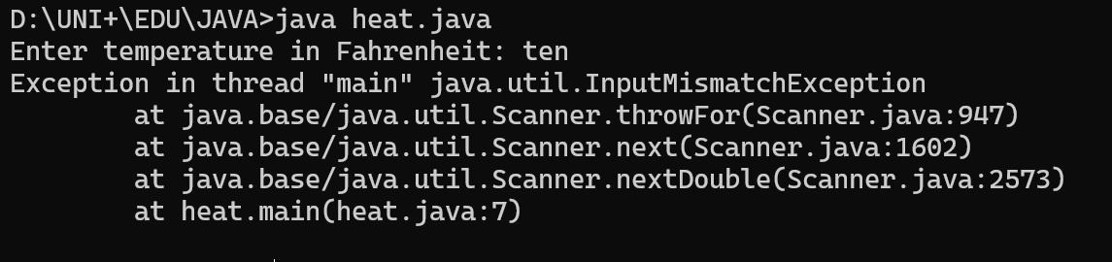
IMPORTANT POINTS:
- import java.util.Scanner; is used to include the Scanner class to take user input.
1.Class Declaration:
- The class is named FahrenheitToCelsius which follows Java naming conventions.
2. Main Method:
- The program execution starts from the main() method:
public static void main(String[] args)
3.Scanner Class:
- The Scanner object is created to take input from the user:
Scanner scanner = new Scanner(System.in);

ERROR TABLE:
S.No | Error type | Reason for error | rectification
1 | Syntax error | Missing ” | “ is added
2 | Missing import error | Util package missing | Util package added

5)Write a java program to convert temperature from Celsius to Fahrenheit
Code:

import java.util.Scanner;

public class temp {
public static void main(String[] args) {
Scanner scanner = new Scanner(System.in);
System.out.print("Enter temperature in Celsius: ");
double celsius = scanner.nextDouble();
double fahrenheit = celsiusToFahrenheit(celsius);
System.out.println("Temperature in Fahrenheit: " + fahrenheit);
scanner.close();
}

public static double celsiusToFahrenheit(double celsius) {
return (celsius * 9/5) + 32;
}
}

Output:
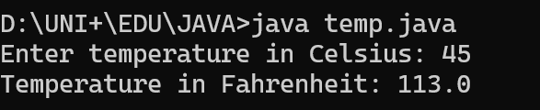
Negative case:
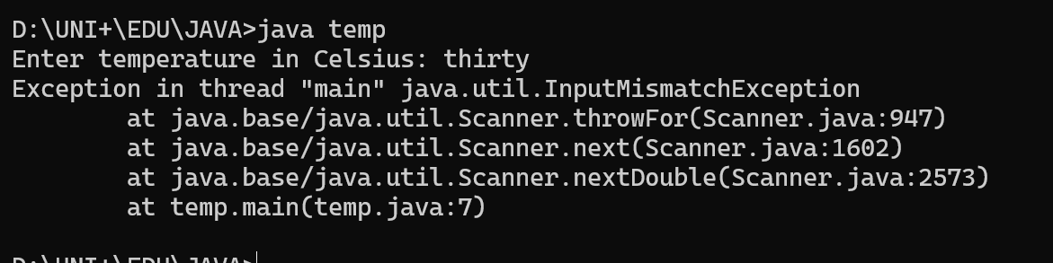

IMPORTANT POINTS:
1. Importing Scanner Class:
- The Scanner class is imported from java.util.Scanner to take user input.
2. Class Declaration:
- The class name CelsiusToFahrenheit follows Java naming conventions (PascalCase).
3. Main Method:
- The public static void main(String[] args) method is the entry point of the program

ERROR TABLE:
S.No | Error type | Reason for error | Rectification
1 | Runtime error | Incorrect path selection | Correct path added
2 | Logical error | Incorrect logic | Correct logic

6)AIM: WRITE A JAVA PROGRAM TO FIND THE AREA OF A RECTANGLE
PROGRAM:
Positive case:
import java.util.Scanner;

public class RectangleArea {
public static void main(String[] args) {
Scanner scanner = new Scanner(System.in);
System.out.print("Enter the length of the rectangle: ");
double length = scanner.nextDouble();
System.out.print("Enter the width of the rectangle: ");
double width = scanner.nextDouble();
double area = calculateArea(length, width);
System.out.println("The area of the rectangle is: " + area);
scanner.close();
}

public static double calculateArea(double length, double width) {
return length * width;
}
}

Output:
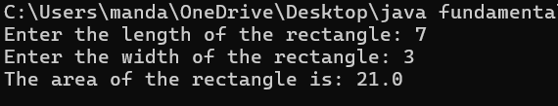
Negative case:
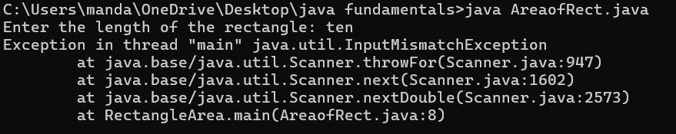
ERROR TABLE:
S.No | Error type | Reason for error | Rectification
1 | Syntax error | Semi colon missing | Semi colon added
2 | Missing import error | Import package missing | Import package added

IMPORTANT POINTS:
1. Purpose: The program calculates the area of a rectangle based on the user-provided length and width.
2. User Input:
- It prompts the user to input the rectangle's length and width.
- The input is read using the Scanner class and stored as double values to allow for decimal measurements.
3.Modularity:
- The calculation logic is placed in a separate method, calculateArea(), which takes length and width

7)AIM: WRITE A JAVA PROGRAM TO FIND THE AREA OF A TRIANGLE
PROGRAM:
Positive case:
import java.util.Scanner;

public class TriangleArea {
public static void main(String[] args) {
Scanner scanner = new Scanner(System.in);
System.out.print("Enter the base of the triangle: ");
double base = scanner.nextDouble();
System.out.print("Enter the height of the triangle: ");
double height = scanner.nextDouble();
double area = calculateArea(base, height);
System.out.println("The area of the triangle is: " + area);
scanner.close();
}

public static double calculateArea(double base, double height) {
return (base * height) / 2;
}
}
OUTPUT:
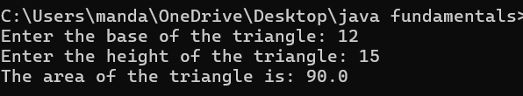
Negative case:
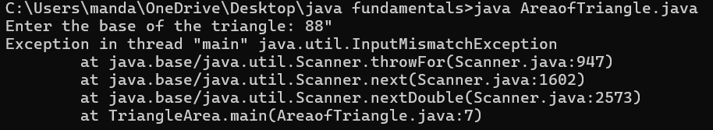
ERROR TABLE:
S.No | Error type | Reason for error | rectification
2. | Runtime errror | Incorrect path | Using correct path
3. | Syntax error | No semicoln | Using semicoln

IMPORTANT POINTS:
User Input:
- The user is prompted to enter:
  - Base of the triangle
  - Height of the triangle
Method Call:
- The method calculateArea(base, height) is called to calculate the area of the triangle.
Return Value:
- The method returns the area value to the main() method.

WEEK-3
1)Aim:
To create java program with following instructions
1.Create a class with name car
2. Create four attributes named car colour ,Car brand, fuel type, mileage
3. Create three methods named start(), stop(). Service()
4. Create three objects named car1, car2 and car3
CLASS DIAGRAM:
car
+Car_color: String
+ Car_brand: String
+ fuel_type: String
+ mileage: int
+ start(): void
+ service(): void
+ stop(): void
PROGRAM:
import java.util.*;
class car
{

public String Car_color;
public String Car_brand;
public String fuel_type;
public int mileage;
public void start()
{

System.out.println("Car Started:");
System.out.println("Car color is :"+Car_color);
System.out.println("Car Brand is:"+Car_brand);
System.out.println("Car fuel type is:"+fuel_type);
System.out.println("Car mileage is:"+mileage);
}
public void service()

{
System.out.println("Car Started:");
System.out.println("Car color is :"+Car_color);
System.out.println("Car Brand is:"+Car_brand);
System.out.println("Car fuel type is:"+fuel_type);
System.out.println("Car mileage is:"+mileage);
}
public void stop()

{
System.out.println("Car Started:");
System.out.println("Car color is :"+Car_color);
System.out.println("Car Brand is:"+Car_brand);
System.out.println("Car fuel type is:"+fuel_type);
System.out.println("Car mileage is:"+mileage);
}
public static void main(String args[])
{ System.out.println("\nNIKHIL\n\n");
car car1 = new car();
car1.Car_color = "Blue";
car1.Car_brand = "Audi";
car1.fuel_type = "Deisel";
car1.mileage = 100;
car1.start();
car car2 = new car();
car2.Car_color = "Red";
car2.Car_brand = "Tesla";
car2.fuel_type = "EV";
car2.mileage = 200;
car2.stop();
car car3 = new car();
car3.Car_color = "Yellow";
car3.Car_brand = "BMW";
car3.fuel_type = "Petrol";
car3.mileage = 300;
car3.service();

}
}
OUTPUT:
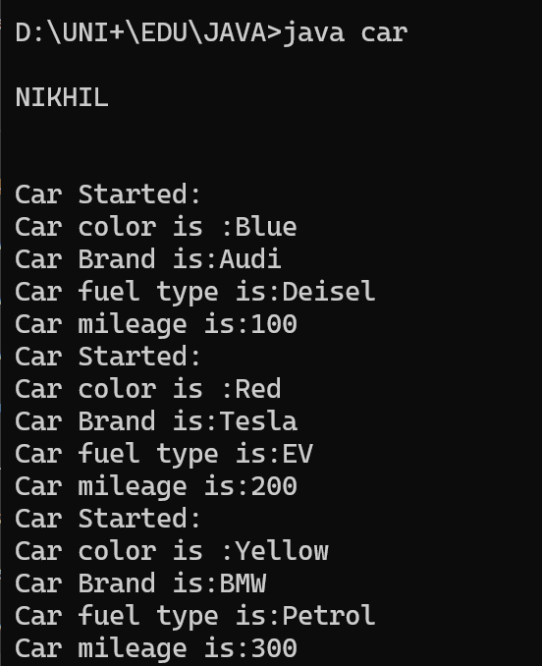
S.No | Error type | Reason for error | rectification
2. | Runtime errror | Incorrect path | Using correct path
3. | Syntax error | No semicoln | Using semicoln
ERROR TABLE:
IMPORTANT POINTS:
1. The car class has four attributes: Car_color, Car_brand, fuel_type, and mileage.
2. It also has three methods: start(), service(), and stop().
3. The start(), service(), and stop() methods all print the same details about the car.
4. Each method prints the car's color, brand, fuel type, and mileage to the console
5. The main method creates three instances of the car class: car1, car2, and car3.
6. Each car object is assigned specific values for Car_color, Car_brand, fuel_type, and mileage.
2)AIM:
WRITE A JAVA CLASS FOR A BANK ACCOUNT WITH DEPOSIT() AND WITHDRAW() AS METHODS.
CLASS DIAGRAM:
BankAccount
-balance: double
+BankAccount(doubleinitialBalance
+deposit(doubleamount): void
+ getBalance(): double

PROGRAM:
class BankAccount {
private double balance;

public BankAccount(double initialBalance) {
if (initialBalance > 0) {
this.balance = initialBalance;
} else {
this.balance = 0;
}
}

public void deposit(double amount) {
if (amount > 0) {
balance += amount;
System.out.println("Deposited $:" + amount);
} else {
System.out.println("Deposited amount must be positive");
}
}

public double getBalance() {
return balance;
}
}

public class Main1 {
public static void main(String args[]) {
BankAccount account = new BankAccount(50000);
account.deposit(25000);
System.out.println("Current Balance is:" + account.getBalance());
}
}
OUTPUT:

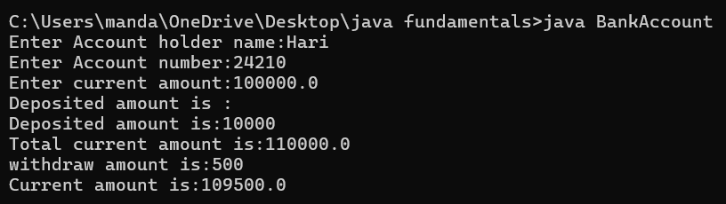
ERROR TABLE:
S.No | Error type | Reason for error | rectification
2. | Runtime errror | Incorrect path | Using correct path
3. | Syntax error | No semicoln | Using semicoln
IMPORTANT POINTS:
The Bank Account class has a private attribute balance to store the account balance.
- The class has a constructor, BankAccount(double initialBalance), which initializes the balance. If the initial balance is not positive, it sets the balance to 0.
- The deposit(double amount) method adds a positive amount to the balance and prints a message. If the deposit amount is not positive, it prints an error message.
- The getBalance() method returns the current balance of the account.
- The Main1 class contains the main method, which serves as the entry point of the program.
- In the main method, an instance of Bank Account is created with an initial balance of 1000.

WEEK-4
1)AIM- WRITE A JAVA PROGRAM WITH CLASS NAMED “Book”. THE CLASS SHOUKD CONTAIN VARIOUS ATTRIBUTES SUCH AS TITLE, AUTHOR, YEAR OF PUBLICATION. IT SHOULD ALSO CONTAIN A CONSTRUCTOR WITH PARAMETERS WHICH INITIALIZES TITLE, AUTHOR, YEAR OF PUBLICATION AND CREATE A METHOD WHICH DISPLAYS THE DETAILS OF 2 BOOKS.

CLASS DIAGRAM:
Book
+title: String
+author: String
+year: int
+ Book(title: String, author:String, year: int) + displayDetails(): void

PROGRAM:
class book
{
public String Title;
public String Author;
public int YearofPublication;
book(String Title, String Author,int YearofPublication)
{
this.Title=Title;
this.Author=Author;
this.YearofPublication= YearofPublication;

}
public void Details()
{
System.out.println("Title of the book:"+Title);
System.out.println("Author of the book:"+Author);
System.out.println("Year of Publication of the book:"+YearofPublication);
}
public static void main(String args[])
{
book b1=new book("JAVA Programming Language", "Dr.Suresh",2020);
b1.Details() ;
book b2=new book("Physics", "Dr.Sujata",2009);
b2.Details();
}
}
OUTPUT:
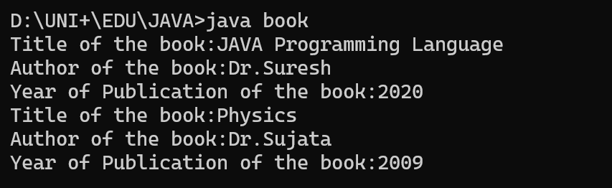
NEGATIVE CASE: 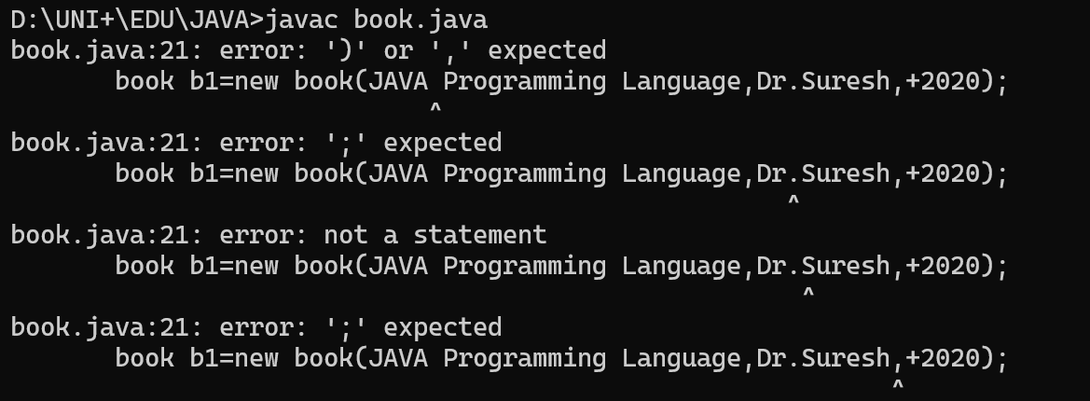
ERROR TABLE:
S.No | ERROR TYPE | Reason for error | Rectification
1. | Syntax error | No semicolon | Semicolon added
2. | Runtime error | Incorrect path | Copied correct path
IMPORTANT POINTS:
1. Constructor:
- The constructor Book(String, String, int) is used to initialize the object when it is created.
- The keyword this is used to differentiate between class attributes and constructor parameters.
2.Method:
- The method displayDetails() is used to display the book details.
- The System.out.println() method prints the details to the console.
3. Object Creation:
- Two objects b1 and b2 are created using the constructor.

2)AIM- WRITE A JAVA PROGRAM WITH CLASS NAMED “MyClass” WITH A STATIC VARIABLE COUNT OF INT TYPE. INTIALIZE IT TO ZERO AND A CONSTANT VARIABLE “Pi” OF TYPE DOUBLE INITIALIZED TO “3.14” AS ATTRIBUTES OF THAT CLASS. NOW DEFINE A CONSTRUCTOR FOR “MyClass”, THAT INCREMENTS THE COUNT VARIABLE EACH TIME AN OBJECT OF “MyClass” IS CREATED. FINALLY, PRINT THE FINAL VALUES OF ‘COUNT’ AND ‘PI’ VARIABLES AND CREATE 3 OBJECTS.
CLASS DIAGRAM:
MyClass
-count: int (static)
-pi: double (static, final)
+MyClass()
+main(args: String[]):void

PROGRAM:
public class MyClass {
static int count = 0;
static final double pi = 3.14;

MyClass() {
count++;
}

public static void main(String[] args) {
MyClass obj1 = new MyClass();
MyClass obj2 = new MyClass();
MyClass obj3 = new MyClass();

System.out.println("Count: " +count);
System.out.println("Pi: " +pi);
}
}
OUTPUT:
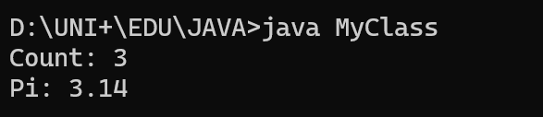
NEGATIVE CASE:
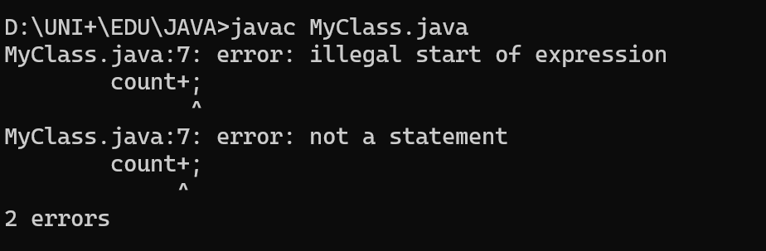
ERROR TABLE:
S.No | Error Type | Reason for error | Rectification
1. | No class | No class name declared | Created class named ‘MyClass’
2. | Syntax error | Not added keyword | Added keyword named ‘new’

IMPORTANT POINTS:
1.Static Keyword
- Static members belong to the class, not to individual objects.
- Only one copy of the static variable is maintained for all objects.
2.Static Variable
- static int count:
  - Shared among all objects of the class.
  - It is initialized only once and not for every object.
  - It increments every time the constructor is called.
3.Final Variable
- static final double pi:
  - The final keyword makes the variable constant.
  - Its value cannot be changed once assigned.
  - It must be initialized at the time of declaration.

WEEK-5
1)AIM:
Create a calculator using the operations including addition, subtraction, multiplication,
and division using multilevel inheritance and display the desired output.
Class Diagram:
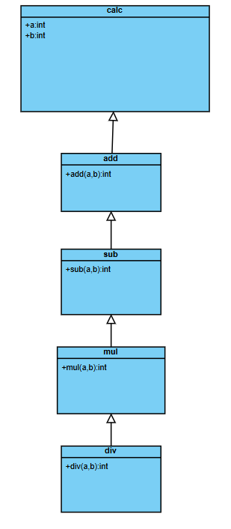

Program:
class addition {
public int add(int a, int b) {
int addition = a + b;
return addition;
}
}

class subtraction extends addition {
public int sub(int a, int b) {
int subtraction = a - b;
return subtraction;
}
}

class multiplication extends subtraction {
public int mul(int a, int b) {
int multiplication = a * b;
return multiplication;
}
}

class division extends multiplication {
public int div(int a, int b) {
int division = a / b;
return division;
}
}

class calculator {
public static void main(String args[]) {
division obj = new division();
System.out.println(obj.add(4, 8));
System.out.println(obj.sub(4, 8));
System.out.println(obj.mul(4, 8));
System.out.println(obj.div(4, 8));
}
}
OUTPUT:
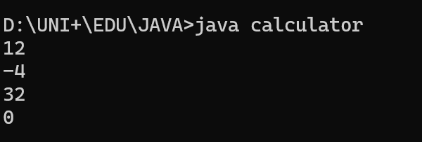
ERROR TABLE:
S.No | Error type | Reason for error | rectification
2. | Runtime errror | Incorrect path | Using correct path
3. | Syntax error | No semicoln | Using semicoln
IMPORTANT POINTS:
- Multi-Level Inheritance
  - Classes form a chain: addition → subtraction → multiplication → division.
  - Each child inherits all methods from its parent.
- Incremental Method Addition
  - Each class adds one new arithmetic operation (add, sub, mul, div).
- Single Object Access to All Methods
  - A division object can perform all operations (add, sub, mul, div) due to inheritance.
- Integer Division Limitation
  - div(4, 8) returns 0 (truncated). Should use double for accurate results.
- Poor Real-World Design
  - Misuse of inheritance (operations aren’t hierarchical). Better to use a single class or interfaces
2)AIM:
A vehicle rental company wants to devlop a system that maintains information about different types of vehicles available for rent. The company rents out cars , bikes and trucks and they need a program to store details about each vehicle, such as brand and speed.
=>Cars should have an additional property such as number_of_doors .
=>Bikes should have a property indicating whether they have gears or not.
=>Truck should have a property of their capacity(in tons).
=>Every class should have a constructor.
Class Diagram:
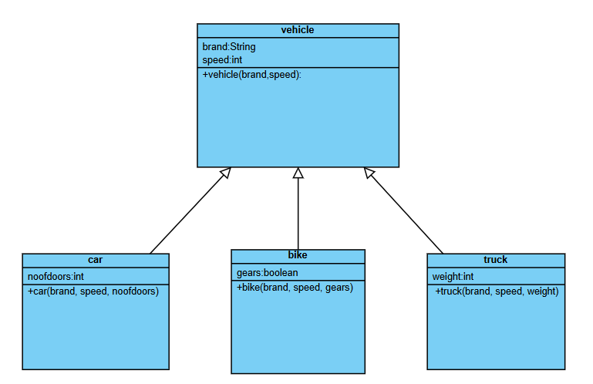
Program:
class vehicle{
String brand;
int speed;

public vehicle(String brand,int speed){
this.brand=brand;
this.speed=speed;
}

public static void main(String[] args) {

car obj1=new car("ford",34,4);
bike obj2=new bike("hero",100,true);
truck obj3=new truck("tata",60,40);

}
}

class car extends vehicle{

int noofdoors;

public car(String brand, int speed,int noofdoors) {
super(brand, speed);
this.noofdoors=noofdoors;
System.out.println("brand of the car is :"+brand);
System.out.println("speed of the car is :"+speed);
System.out.println("number of doors :"+noofdoors);
}
}
class bike extends vehicle{
boolean gears;
public bike(String brand,int speed,boolean gears){
super(brand, speed);
this.gears=gears;
System.out.println("brand of the bike is :"+brand);
System.out.println("speed of the bike is :"+speed);
System.out.println("gears are present :"+gears);
}
}
class truck extends vehicle{
int weight;
public truck(String brand,int speed,int weight){
super(brand,speed);
this.weight=weight;
System.out.println("brand of the truck is :"+brand);
System.out.println("speed of the truck is :"+speed);
System.out.println("weight in tons is :"+weight);
}
}

OUTPUT:
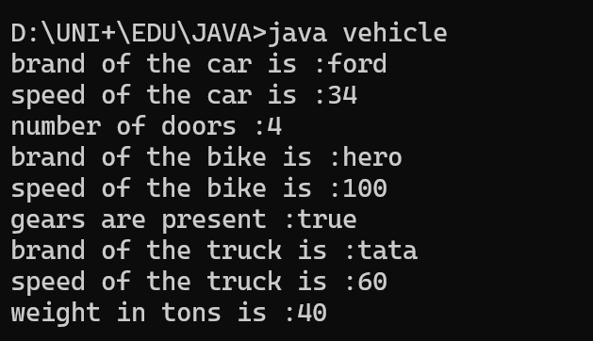
S.No | Error Type | Reason for error | Rectification
1. | No class | No class name declared | Created class named ‘MyClass’
2. | Syntax error | Not added keyword | Added keyword named ‘new’
ERROR TABLE:

IMPORTANT POINTS:
- Vehicle is the parent/super class
- Car, Bike, and Truck are child/subclasses that inherit from Vehicle
- Each class shows:
  - Class name at the top
  - Attributes in the middle section (with visibility: - for private)
  - Constructors in the bottom section (with visibility: + for public)
- The inheritance relationship is shown with arrows from child to parent class
- Each subclass adds its own specific attributes,Car adds noofdoors
WEEK-6
1)AIM:
Write a java program to create a Vehicle class with a method displayInfo().Override this method in the car subclass to provide specific information about a car.
CLASS DIAGRAM:
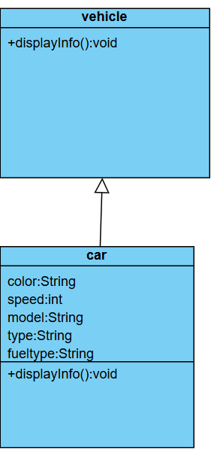
PROGRAM:
class vehicle1{
public void displayInfo(){
System.out.println("This is a vehicle.");
}
}

class car1 extends vehicle1{
String color = "red";
int speed = 120;
String model = "Toyota";
String type = "SUV";
String fuelType = "Petrol";

public void displayInfo(){
System.out.println("This is a car.");
System.out.println("Color: " + color);
System.out.println("Speed: " + speed + " km/h");
System.out.println("Model: " + model);
System.out.println("Type: " + type);
}
}

class Override{
public static void main(String[] args) {
System.out.println("M.NIKHIL SAI 24211 CSE-C");

vehicle1 v = new vehicle1();
v.displayInfo(); // Calls the method from the vehicle(super) class

car1 c = new car1();
c.displayInfo(); // Calls the overridden method from the car(sub) class
}
}
OUTPUT:
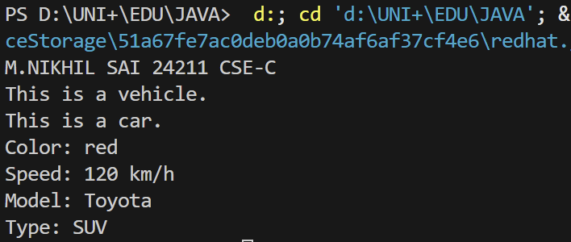
ERROR:
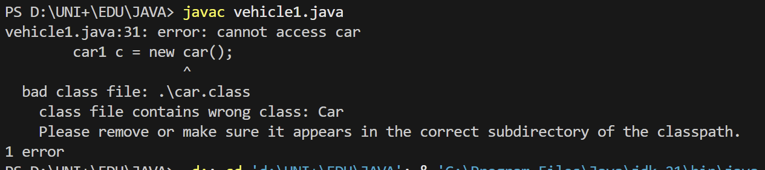
IMPORTANT POINTS:
=>Here class vehicle and car share a single level inheritance between them.
=>Here in the above code is an example of method overriding in java where the method names and their signature are same in both super class and sub class.

2)AIM:
A college is developing an automated admission system that verifies student’s eligibility for Undergraduate(UG) and Postgraduate(PG) programs. Each program has different eligibility criteria based on the student’s percentage in their previous qualification.

CONDITION:
1.UG admission require minimum of 60%.
2.PG admission require minimum of 70%.
CLASS DIAGRAM:
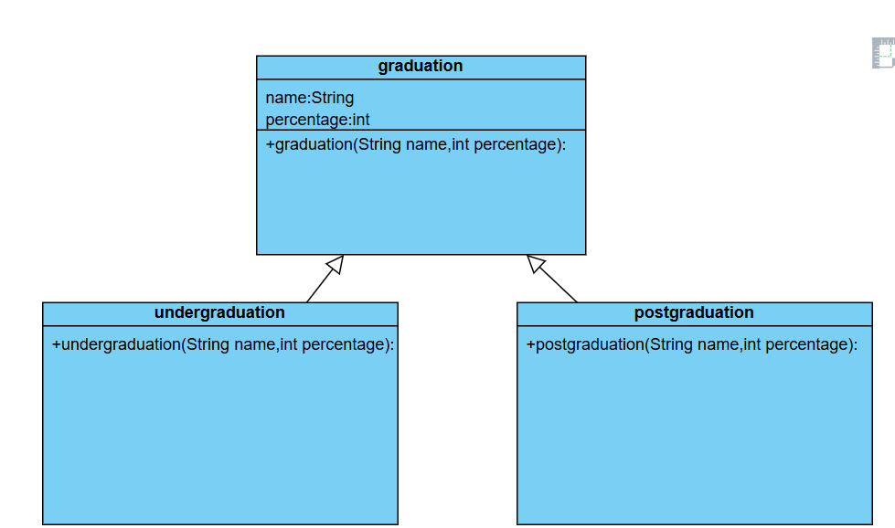
PROGRAM:
class student{
String name;
double percentage;
public student(String name,double percentage){
this.name=name;
this.percentage=percentage;
}
void eligibility(){
System.out.println(name+" must have the foolowing criteria");
}
}
class UG extends student{
UG(String name,double percentage){
super(name,percentage);
}
void eligibility(){
if(percentage>=60){
System.out.println(name+" is eligible for ug");
}
else{
System.out.println(name+"is not eligible for ug");
}
}
}
class PG extends student{
PG(String name,double percentage){
super(name,percentage);
}
void eligibility(){
if(percentage>=70.0){
System.out.println(name+" is not eligible for pg");
}
else{
System.out.println(name+" is eligible for pg");
}
}
}
class collegeadmission{
public static void main(String[] args){
student s1=new student("Nikhil",80.0);
s1.eligibility();
student s2=new student("Nikhil",50.0);
s2.eligibility();
PG s=new PG("Nikhil",70.0);
s.eligibility();
UG u=new UG("Nikhil",60.0);
u.eligibility();
}
}
OUTPUT:
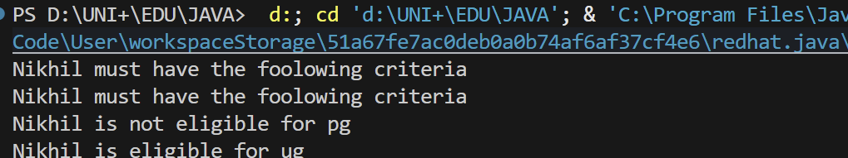
ERROR:
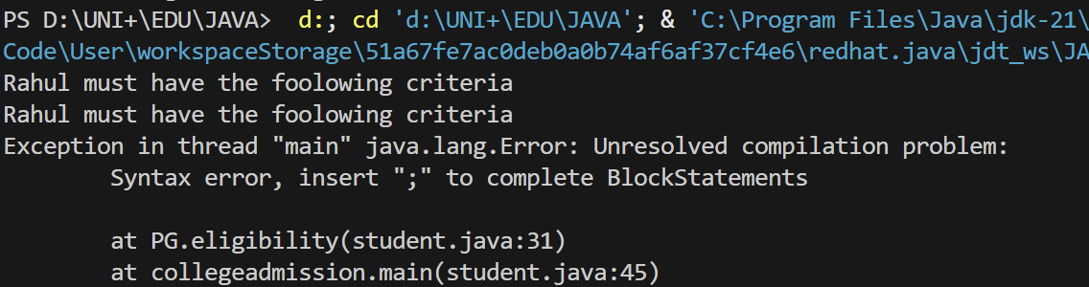
IMPORTANT POINTS:
Here classes undergraduation and postgraduation share a Hierarchical inheritance with graduation class.
For each class there is a respective constructor used for the values name and percentage
super(name, percentage); Call the constructor of the superclass (graduation).

3)AIM:
Create a calculator class with overloaded methods to perform addition:
1.add two integers
2.add 2 doubles
3.add 3 integers
CLASS DIAGRAM:
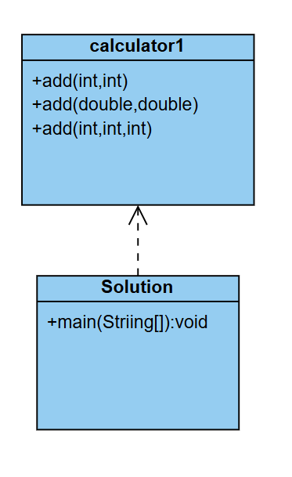
PROGRAM:
class calculator1{
public void add(int num1, int num2){
int num=num1+num2;
System.out.println("sum of two integers is "+num);
}
public void add(double num1,double num2){
double num=num1 +num2;
System.out.println("sum of two floating integers is "+num);
}
public void add(int num1,int num2,int num3){
int num = num1+num2+num3;
System.out.println("sum of three integers is "+num);
}
}
public class Solution{
public static void main(String[] args){
System.out.println("M.NIKHIL SAI,24211,CSE-C");
calculator1 calculator= new calculator1();
calculator.add(10,30);
calculator.add(10.5,30.6);
calculator.add(10,30,40);
}
}

OUTPUT:
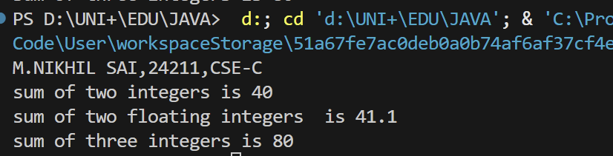
ERROR:
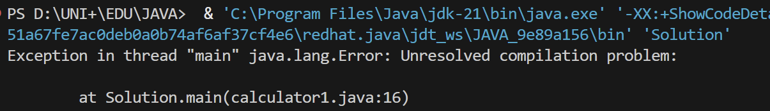
IMPORTANT POINTS:
The calculator1 class demonstrates method overloading by defining
multiple add() methods with the same name but different parameters.
Number of parameters (add(int, int) vs add(int, int, int))
Data types of parameters (add(int, int) vs add(double, double))
add(int num1, int num2) → Adds two integers.
add(double num1, double num2) → Adds two floating-point numbers.
add(int num1, int num2, int num3) → Adds three integers.
Each method prints a different message based on the type and number of arguments.

4)AIM:
Create a shape class with a method “calculateArea()” that is overloaded for different shapes(ex:square,rectangle,triangle).then create a subclass “Circle” that overrides the calcArea() method for a circle.

CLASS DIAGRAM:
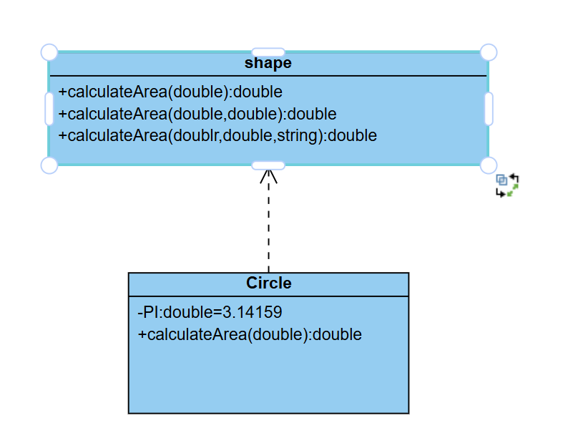
PROGRAM:
class shape {
public double calculateArea(double side) {
return side * side;
}
public double calculateArea(double length, double width) {
return length * width;
}
public double calculateArea(double base, double height, String shape) {
if (shape.equalsIgnoreCase("triangle")) {
return 0.5 * base * height;
}
return 0;
}
}

class Circle extends shape {
private static final double PI = 3.14159;
public double calculateArea(double radius) {
return PI * radius * radius;
}
}

public class AreaCalculator {
public static void main(String[] args) {
System.out.println("M.NIKHIL SAI,24211,CSE-C");
shape shape = new shape();
Circle circle = new Circle();

System.out.println("Area of square (side=5): " + shape.calculateArea(5));
System.out.println("Area of rectangle (4x6): " + shape.calculateArea(4, 6));
System.out.println("Area of triangle (base=3, height=4): " +
shape.calculateArea(3, 4, "triangle"));
System.out.println("Area of circle (radius=5): " + circle.calculateArea(5));
}
}

OUTPUT:
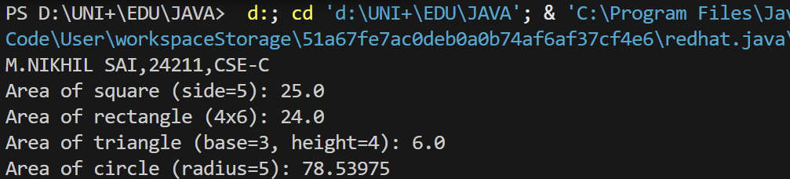
ERROR:
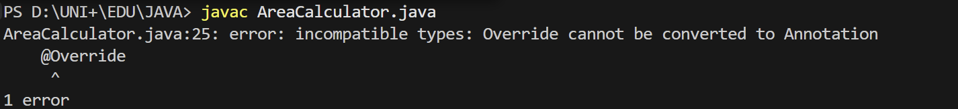
IMPORTANT POINTS:
- The shape class demonstrates method overloading with three calculateArea() methods:
  - calculateArea(double side) → Computes the area of a square (side * side).
  - calculateArea(double length, double width) → Computes the area of a rectangle (length * width).
  - calculateArea(double base, double height, String shape) → Computes the area of a triangle (0.5 * base * height).
- The Circle class inherits from shape and overrides calculateArea() to compute the area of a circle (π * radius²).
- Uses a private static final constant PI for the value of π.
- The Circle class overrides the calculateArea() method to provide its own implementation.

WEEK-7
1)AIM:
Write a java program to create an abstract class Animal with an abstract method called Sound(). Create subclasses Lion and Tiger that extend the Animal class and implement the Sound() to make a specific sound for each animal.
CLASS DIAGRAM:
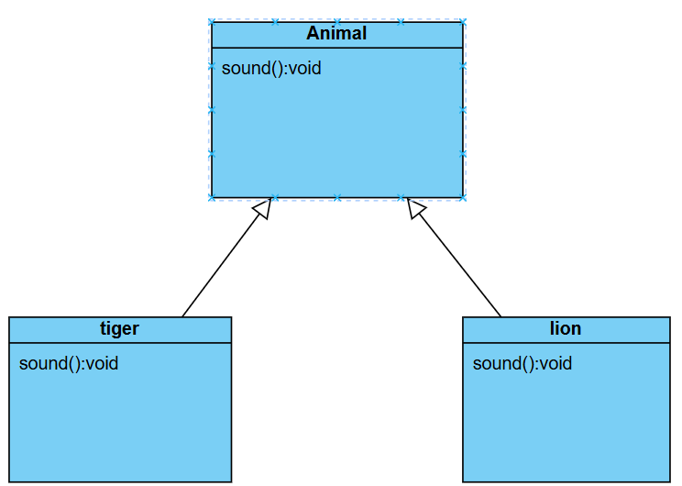
PROGRAM:
abstract class Animal {
abstract void sound();
}

class Lion extends Animal {
public void sound() {
System.out.println("Lion Roars");
}
}

class Tiger extends Animal {
public void sound() {
System.out.println("Tiger growls");
}
}

public class AbstractDemo {
public static void main(String[] args) {
System.out.println("M.NIKHIL SAI,24211,CSE-C");
Lion L = new Lion();
Tiger T = new Tiger();
L.sound();
T.sound();
}
}
OUTPUT:
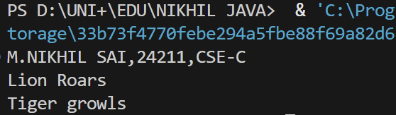
ERROR TABLE:
S.No | Error type | Reason for error | rectification
2. | Runtime errror | Incorrect path | Using correct path
3. | Syntax error | No semicoln | Using semicolon

IMPORTANT POINTS:
- Abstract Class (Animal)
  - Defines an abstract method sound() with no implementation.
  - Cannot be instantiated directly (cannot create Animal objects).
- Concrete Subclasses (Lion and Tiger)
  - Inherit from Animal and must implement the sound() method.
  - Lion → Prints "Lion Roars".
  - Tiger → Prints "Tiger growls".
2)AIM:
Write a java program to create an abstract class Shape3D with abstract methods calculateVolume() and calculateSurfaceArea() method .Create subclasses Sphere and Cube that extend the Shape3D class and Implements the respective methods to calculate the Volume and Surface area of each Shape.
CLASS DIAGRAM:
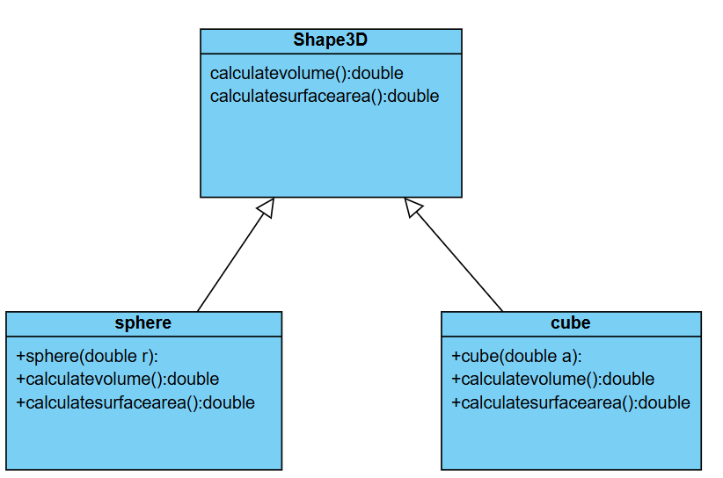
PROGRAM:
abstract class Shape3D{
abstract double calculateVolume();
abstract double calculateSurfaceArea();
}
class Sphere extends Shape3D{
int radius;
Sphere(int radius){
this.radius=radius;
}

public double calculateVolume(){
return (4.0/3.0)*Math.PI*Math.pow(radius,3);
}
public double calculateSurfaceArea(){
return 4*Math.PI*Math.pow(radius,2);
}
}
class Cube extends Shape3D{
int edge;
Cube(int edge){
this.edge=edge;
}

public double calculateVolume(){
return Math.pow(edge,3);
}
public double calculateSurfaceArea(){
return 6*Math.pow(edge,2);
}
}
public class Abstract{
public static void main(String[] args) {
System.out.println("M.NIKHIL SAI,24211,CSE-C");
Sphere sphere=new Sphere(5);
System.out.println("Volume of sphere is "+sphere.calculateVolume());
System.out.println("Surface area of sphere is "+sphere.calculateSurfaceArea());
Cube cube=new Cube(5);
System.out.println("Volume of cube is "+cube.calculateVolume());
System.out.println("Surface Area of cube is "+cube.calculateSurfaceArea());
}
}
OUTPUT:
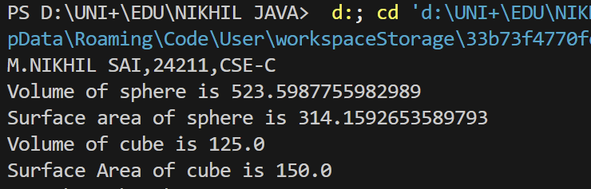
ERROR TABLE:
S.No | Error Type | Reason for error | Rectification
1. | No class | No class name declared | Created class named ‘Absract’
2. | Syntax error | Not added keyword | Added keyword named ‘new’

IMPORTANT POINTS:
1. Abstract Class (Shape3D)
- Defines two abstract methods:
  - calculateVolume() → Computes the 3D shape's volume.
  - calculateSurfaceArea() → Computes the surface area.
- Cannot be instantiated directly (must be extended by subclasses).
2. Subclasses (Sphere and Cube)
- Extend Shape3D and must implement both abstract methods.
- Sphere Class:
  - Takes radius as input in the constructor.
  - Volume Formula: (4/3)πr³
  - Surface Area Formula: 4πr²
- Cube Class:
  - Takes edge (side length) as input in the constructor.
  - Volume Formula: edge³
  - Surface Area Formula: 6 × edge²
3)AIM:
Write a java program using an abstract class to define a method for pattern printing.
create an abstract class named PatternPrinter with an abstract method PrintPattern(int n) and a concrete method to display the pattern title
Implement two subclasses:
1)Star pattern -prints a right angled triangle of stars(*)
2)Number pattern-prints a right angled triangle of increasing numbers
In the main() method ,create objects of both subclasses and print the patterns for a given number of rows
CLASS DIAGRAM:
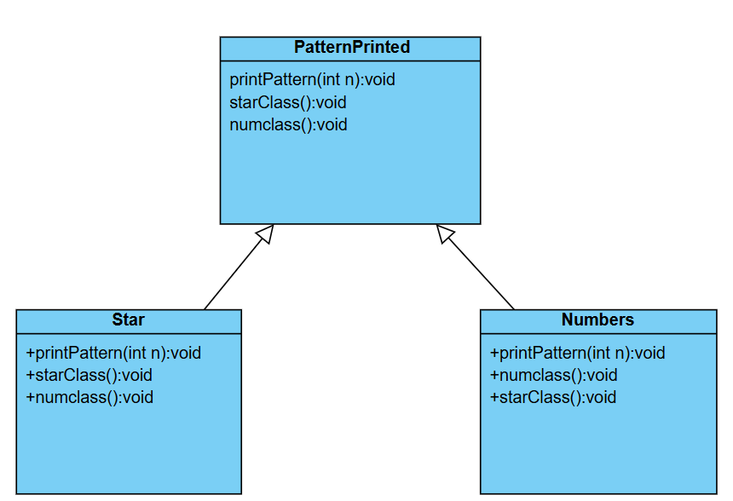
PROGRAM:
abstract class PatternPrinter {
abstract void printPattern(int n);
void displayTitle(String title) {
System.out.println("\n" + title + " Pattern:");
System.out.println("-------------------");
}
}
class StarPattern extends PatternPrinter {
@Override
void printPattern(int n) {
displayTitle("Star");
for (int i = 1; i <= n; i++) {
for (int j = 1; j <= i; j++) {
System.out.print("* ");
}
System.out.println();
}
}
}
class NumberPattern extends PatternPrinter {
@Override
void printPattern(int n) {
displayTitle("Number");
int num = 1;
for (int i = 1; i <= n; i++) {
for (int j = 1; j <= i; j++) {
System.out.print(num++ + " ");
}
System.out.println();
}
}
}
public class Pattern{
public static void main(String[] args) {
System.out.println("M.NIKHIL SAI,24211,CSE-C");
int rows = 5;
PatternPrinter starPrinter = new StarPattern();
PatternPrinter numberPrinter = new NumberPattern();
starPrinter.printPattern(rows);
numberPrinter.printPattern(rows);
}
}
OUTPUT:
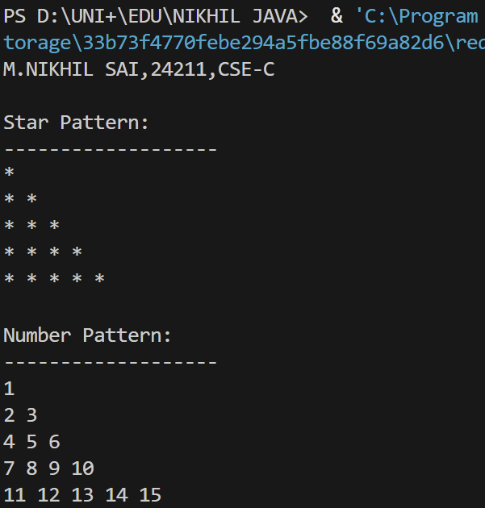
NEGATIVE CASE:
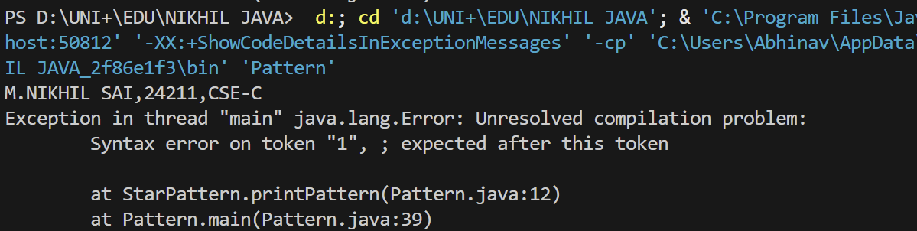
ERROR TABLE:
S.NO | Error type | Error Rectification
1 | Logical error in wrong formula | Formula Rectified
2 | Runtime error in incorrect path | Copied correct path
IMPORTANT POINTS:
1. Abstract Class (PatternPrinter)
- Defines:
  - Abstract Method → printPattern(int n) (must be implemented by subclasses).
  - Concrete Method → displayTitle(String title) (prints a formatted pattern title).
- Cannot be instantiated directly (must be extended).
2. Subclasses (StarPattern and NumberPattern)
- Extend PatternPrinter and override printPattern(int n).
- StarPattern:
  - Prints a right-angled triangle of stars (*)
NumberPattern:
- Prints a right-angled triangle of increasing numbers.

WEEK-8
1)AIM:
Write a java program to create an interface Shape with the getPerimeter() method . Create three classes Rectangle, Circle, Triangle that implement the Shape interface ,Implement the getPerimeter() method for each of the three classes.
CLASS DIAGRAM:
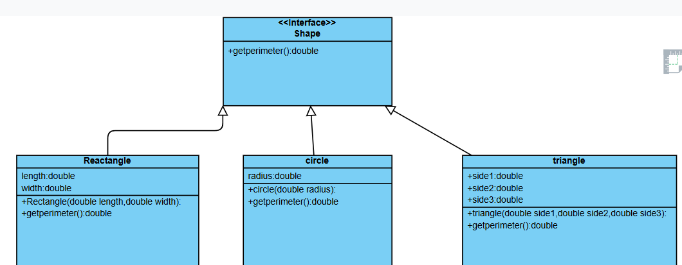
PROGRAM:
interface Shape{
double getPerimeter();
}
class Rectangle implements Shape{
double length;
double width;
Rectangle(double length,double width){
this.length=length;
this.width=width;
}

public double getPerimeter(){
return 2*(length+width);
}
}
class Circle implements Shape{
double radius;
Circle(double radius){
this.radius=radius;
}
public double getPerimeter(){
return 2*3.14*radius;
}
}
class Triangle implements Shape{
double s1;
double s2;
double s3;
Triangle(double s1,double s2,double s3){
this.s1=s1;
this.s2=s2;
this.s3=s3;
}
public double getPerimeter(){
return s1+s2+s3;
}
}
public class Result{
public static void main(String[] args){
System.out.println("M.NIKHIL SAI,24211,CSE-C");
Rectangle r=new Rectangle(10.0,6.0);
Circle c=new Circle(5.0);
Triangle t=new Triangle (5.0,6.0,8.0);
System.out.println("Rectangle Perimeter:"+r.getPerimeter());
System.out.println("Circle Perimeter:"+c.getPerimeter());
System.out.println("Triancle Perimeter:"+t.getPerimeter());
}
}
OUTPUT:
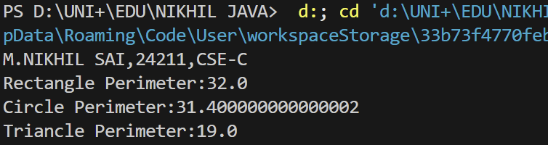
S.NO | Error Name | Error Rectification
1 | Syntax error in closing brackets | Need to close brackets
2 | Wrong syntax in string | Rectified by changing the string
ERROR TABLE:

IMPORTANT POINTS:
1. Interface (Shape)
- Defines one abstract method:
  - getPerimeter() → Must be implemented by all classes that implement Shape.
- Promotes polymorphism → Allows different shapes to be treated uniformly.
2. Implementing Classes (Rectangle, Circle, Triangle)
- Each implements Shape and provides its own getPerimeter() logic:
  - Rectangle → 2 × (length + width)
  - Circle → 2 × π × radius (approximated as 2 × 3.14 × radius)
  - Triangle → side1 + side2 + side3
3. Polymorphism & Method Overriding
- Same method name (getPerimeter()) behaves differently for each shape.
- Runtime binding ensures the correct method is called based on the object type.
2)AIM:
Write a java program to create an interface playable with a method play() that takes no arguments and return void. Create three classes Football, Volleyball, and Basketball that implement the playable interface and override the play() method to play the respective sports.
CLASS DIAGRAM:
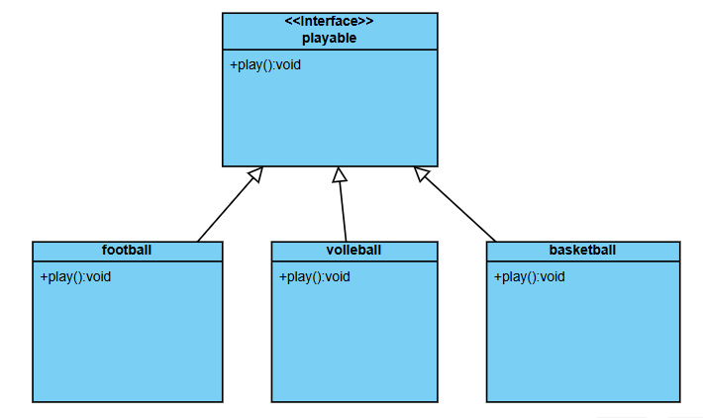
PROGRAM:
interface Playable {
void play();
}
class Football implements Playable {
@Override
public void play() {
System.out.println("Playing Football: Kick the ball and score goals!");
}
}
class Volleyball implements Playable {
@Override
public void play() {
System.out.println("Playing Volleyball: Serve, bump, set, and spike the ball over the net!");
}
}
class Basketball implements Playable {
@Override
public void play() {
System.out.println("Playing Basketball: Dribble, pass, and shoot the ball into the hoop!");
}
}
public class Sports {
public static void main(String[] args) {
System.out.println("M.NIKHIL SAI,24211,CSE-C");
Playable football = new Football();
Playable volleyball = new Volleyball();
Playable basketball = new Basketball();
football.play();
volleyball.play();
basketball.play();
}
}
OUTPUT:
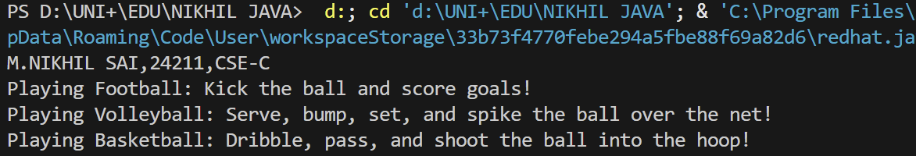
ERROR TABLE:
S.NO | ERROR | RECTIFICATION
1 | Java.lang.error | Execute with “extends” instead of “implements”
IMPORTANT POINTS:
1. Interface Definition (Playable)
- Declares a single abstract method: void play()
- Serves as a contract that implementing classes must follow
- Enables polymorphism by allowing different implementations
2. Implementing Classes
- Football, Volleyball, Basketball all implement Playable
- Each provides its own specific implementation of play()
- Demonstrates how the same method can have different behaviors
3. Polymorphism in Action
- Objects are created using interface reference type (Playable)
- Method calls are resolved at runtime based on actual object type
- Example: football.play() calls Football's implementation
WEEK-9
1)AIM:
Write a java program to create a method that take integers as parameter and throws an exception if the number is even
CLASS DIAGRAM:
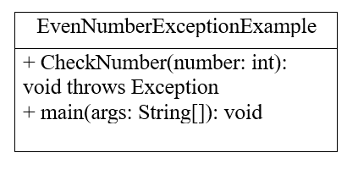
PROGRAM:
package week9;
import java.util.Scanner;
public class EvenNumberException {
public static void checkOddNumber(int number) throws IllegalArgumentException {
if (number % 2 == 0) {
throw new IllegalArgumentException(number + " is an even number. Only odd numbers are allowed.");
}
System.out.println(number + " is an odd number. Accepted!");
}
public static void main(String[] args) {
Scanner scanner = new Scanner(System.in);
try {
System.out.println("M.NIKHIL SAI,CSE-C,24211");
System.out.print("Enter an integer: ");
int input = scanner.nextInt();
checkOddNumber(input);
} catch (IllegalArgumentException e) {
System.out.println("Error: " + e.getMessage());
} catch (Exception e) {
System.out.println("Invalid input. Please enter an integer.");
} finally {
scanner.close();
}
}
}
OUTPUT:
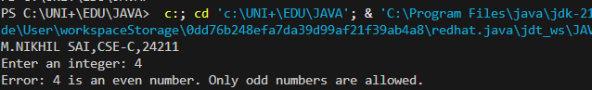
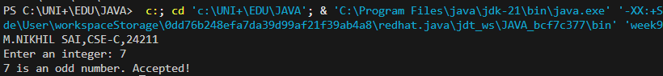
ERROR TABLE:
S.No | Error type | Reason for error | rectification
2. | Runtime errror | Incorrect path | Using correct path
3. | Syntax error | No semicoln | Using semicolon

IMPORTANT POINTS:
- Method checkOddNumber(int number):
  - Takes an integer parameter
  - Checks if the number is even using the modulus operator (%)
  - Throws an IllegalArgumentException if the number is even
  - Prints an acceptance message if the number is odd
- Main Method:
  - Creates a Scanner to get user input
  - Wraps the method call in a try-catch block to handle exceptions
  - Catches both the custom exception for even numbers and general input exceptions
  - Closes the scanner in the finally block
2)AIM:
Write a java program to create a method that reads a file and throws an exception if the file is not found
CLASS DIAGRAM:
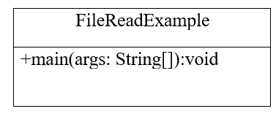
PROGRAM:
package week9;

import java.io.File;
import java.io.FileNotFoundException;
import java.util.Scanner;

public class FileReaderWithException {
public static void readFile(String filePath) throws FileNotFoundException {
File file = new File(filePath);
if (!file.exists()) {
throw new FileNotFoundException("Error: The file '" + filePath + "' was not found.");
}
Scanner scanner = new Scanner(file);
System.out.println("File content:");
System.out.println("------------");
while (scanner.hasNextLine()) {
System.out.println(scanner.nextLine());
}
scanner.close();
}
public static void main(String[] args) {
Scanner inputScanner = new Scanner(System.in);
try {
System.out.print("Enter the path of the file to read: ");
String filePath = inputScanner.nextLine();
readFile(filePath);
} catch (FileNotFoundException e) {
System.out.println(e.getMessage());
} catch (Exception e) {
System.out.println("An unexpected error occurred: " + e.getMessage());
} finally {
inputScanner.close();
}
}
}
OUTPUT: 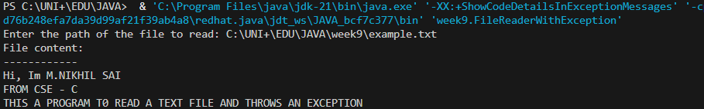
NEGATIVE CASE & ERROR:
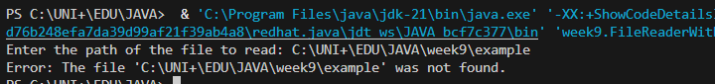
IMPORTANT POINTS:
- Method readFile(String filePath):
  - Takes a file path as input
  - Checks if the file exists using file.exists()
  - Throws FileNotFoundException if the file doesn't exist
  - If file exists, reads and prints its content line by line
- Main Method:
  - Takes user input for the file path
  - Calls readFile() within a try-catch block
  - Handles both the expected FileNotFoundException and other unexpected exceptions
  - Ensures the scanner is closed in the finally block
3)AIM:
write a java program to handle arithmetic exception using try, catch, and finally
CLASS DIAGRAM:
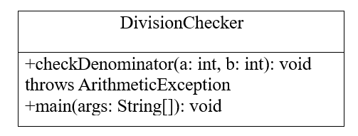
PROGRAM:
package week9;

public class ArithmeticExceptionHandler {
public static void main(String[] args) {
int numerator = 10;
int denominator = 0;
int result;
try {
System.out.println("M.NIKHIL SAI,CSE-C,24211");
result = numerator / denominator;
System.out.println("Result of division: " + result);
}
catch (ArithmeticException e) {
System.out.println("Error: Division by zero is not allowed!");
System.out.println("Exception details: " + e.getMessage());
}
finally {
System.out.println("This block always executes, regardless of whether an exception occurred or not.");
System.out.println("Cleanup or resource release can be done here.");
}
System.out.println("Program continues after exception handling...");
}
}
OUTPUT:
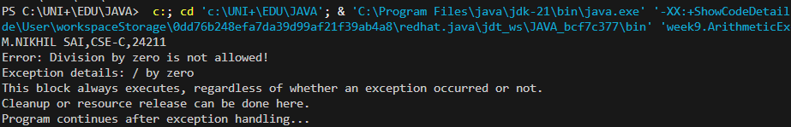
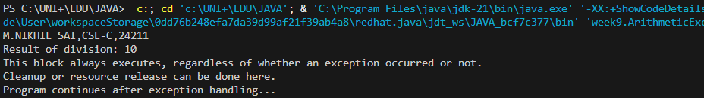
ERROR TABLE:
S.No | Error type | Reason for error | Rectification
1 | Runtime error | Incorrect path selection | Correct path added
2 | Logical error | Incorrect logic | Correct logic
IMPORTANT POINTS:
- Try Block: Contains the code that might throw an exception (division operation in this case).
- Catch Block: Catches the specific ArithmeticException that occurs when dividing by zero. It contains the error handling code.
- Finally Block: Always executes whether an exception occurs or not. Useful for cleanup operations.
- Program Flow:
  - When denominator is 0, an ArithmeticException is thrown
  - The catch block handles it and prints an error message
  - The finally block executes after the catch
  - The program continues after the try-catch-finally structure
4)AIM:
write a java program to stimulate a University system using inner classes
1) Create an outer class named University with a variable universityName
2) inside it, define two non-static inner classes.
3) Department- with variables like deptName and deptCode, and a method to display department details.
4) Student - with variables like studentName and rollNumber and a method to display student details
5) Create an abject for each class and call their methods to display their details along with the University name
CLASS DIAGRAM:
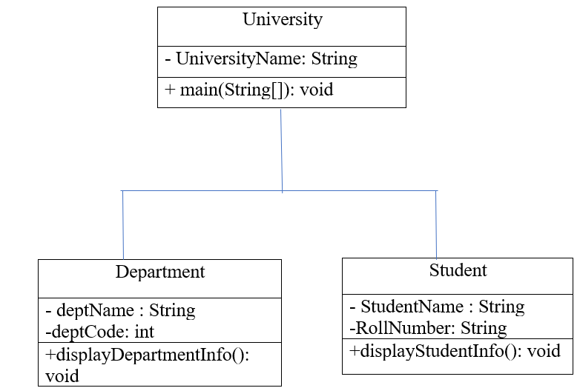

PROGRAM:
package week9;

class University {
String universityName;
public University(String name) {
this.universityName = name;
}
class Department {
String deptName;
String deptCode;
public Department(String name, String code) {
this.deptName = name;
this.deptCode = code;
}
public void displayDepartmentDetails() {
System.out.println("\nDepartment Details:");
System.out.println("University: " + universityName);
System.out.println("Department Name: " + deptName);
System.out.println("Department Code: " + deptCode);
}
}
class Student {
String studentName;
String rollNumber;
public Student(String name, String roll) {
this.studentName = name;
this.rollNumber = roll;
}
public void displayStudentDetails() {
System.out.println("\nStudent Details:");
System.out.println("University: " + universityName);
System.out.println("Student Name: " + studentName);
System.out.println("Roll Number: " + rollNumber);
}
}
}
public class UniversitySystem {
public static void main(String[] args) {
University myUniversity = new University("Amrita University");
University.Department csDept = myUniversity.new Department("Computer Science", "CS101");
University.Student student1 = myUniversity.new Student("M.NIKHIL SAI", "AV.SC.U4CSE24211");
System.out.println("University System Simulation");
System.out.println("============================");
System.out.println("\nUniversity Name: " + myUniversity.universityName);
csDept.displayDepartmentDetails();
student1.displayStudentDetails();
}
}
OUTPUT:
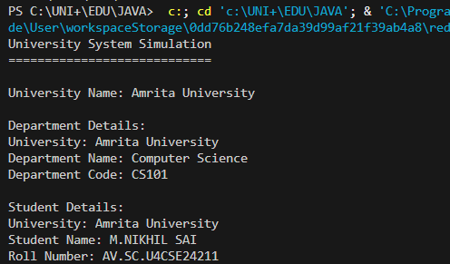
NEGATIVE CASE:
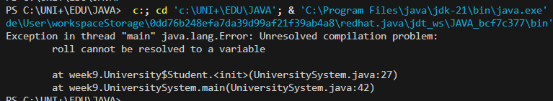
ERROR TABLE:
S.No | Error type | Reason for error | Rectification
1 | Runtime error | Incorrect path selection | Correct path added
2 | Logical error | Incorrect logic | Correct logic

IMPORTANT POINTS:
- Outer Class (University):
  - Contains the university name
  - Houses two inner classes (Department and Student)
- Inner Class (Department):
  - Has department name and code as properties
  - Contains a method to display department details along with university name
- Inner Class (Student):
  - Has student name and roll number as properties
  - Contains a method to display student details along with university name
- Main Class (UniversitySystem):
  - Creates an instance of the University
  - Creates instances of the inner classes (Department and Student)
  - Calls their methods to display details

WEEK-10
1)AIM:
Write a java program to generate a password for a student using his/her initials and age. the password displayed should be the string consists of first character of first name, middle name, last name with age.
CLASS DIAGRAM:
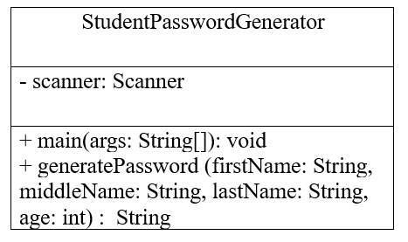

PROGRAM:
import java.util.Scanner;

public class StudentPasswordGenerator {
public static void main(String[] args) {
Scanner scanner = new Scanner(System.in);
System.out.print("Enter first name: ");
String firstName = scanner.nextLine();
System.out.print("Enter middle name: ");
String middleName = scanner.nextLine();
System.out.print("Enter last name: ");
String lastName = scanner.nextLine();
System.out.print("Enter age: ");
int age = scanner.nextInt();
char firstInitial = firstName.charAt(0);
char middleInitial = middleName.charAt(0);
char lastInitial = lastName.charAt(0);
String password = "" + firstInitial + middleInitial + lastInitial + age;
System.out.println("Generated password: " + password);
scanner.close();
}
}
OUTPUT:
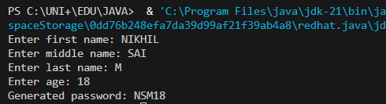
NEGATIVE CASE:
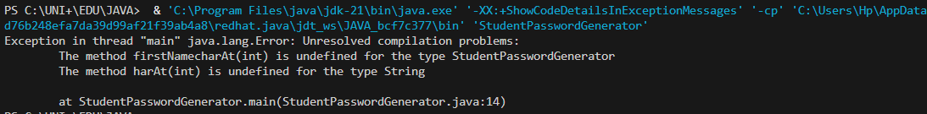

ERROR TABLE:
S.No | Error type | Reason for error | rectification
2. | Runtime errror | Incorrect path | Using correct path
3. | Syntax error | No semicoln | Using semicolon

IMPORTANT POINTS:
- It contains only one class (StudentPasswordGenerator).
- It has two methods:
  - main(): Entry point for execution.
  - generatePassword(): Utility method to create the password.
- Uses Scanner to read user input:
  - Strings: First name, middle name, last name.
  - Integer: Age.
Password Generation Logic
  - Takes the first character of each name (firstName.charAt(0)).
  - Combines initials and age into a single string.

2)AIM:
Design and implement a Java program that will do the following operations to this string "Welcome! You are practicing strings concept."
a. convert all alphabets to capital letters and print out the result.
b. convert all alphabets to lower-case letters and print out the result.
c. print out the length of the string.
d. print out the index of Course.
CLASS DIAGRAM:
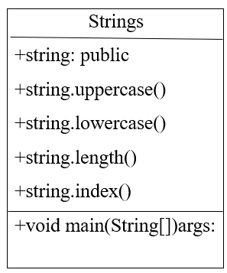
PROGRAM:
public class StringOperations {
public static void main(String[] args) {
System.out.println("M.NIKHIL SAI,CSE-C,24211");
String originalString = "Welcome! You are practicing strings concept.";
String upperCaseString = originalString.toUpperCase();
System.out.println("Uppercase: " + upperCaseString);
String lowerCaseString = originalString.toLowerCase();
System.out.println("Lowercase: " + lowerCaseString);
System.out.println("Length: " + originalString.length());
System.out.println("Index of 'Course': " + originalString.indexOf("Course"));
}
}
OUTPUT:
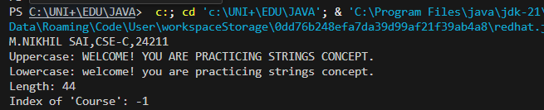
NEGATIVE CASE:
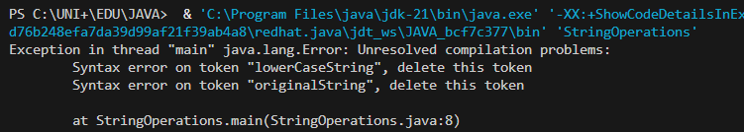
ERROR TABLE:
S.No | Error type | Reason for error | rectification
2. | Runtime errror | Incorrect path | Using correct path
3. | Syntax error | No semicoln | Using semicolon

IMPORTANT POINTS:
- The program defines a string message and displays it.
- It uses touppercsae() and toLowerCase() to change the case of the string.
- Length() is used to find the length of the string
- IndexOf() returns 0, because the stirng is searching for itself at index0.

3)AIM:
Implement a java program using the below array methods.
a. Sorting the elements (numbers and Strings) of an array.
b. convert the array elements into string.
c. fill the part of an array.
d. copy the elements of one array into another.
CLASS DIAGRAM:
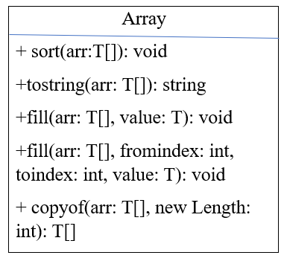
PROGRAM:
import java.util.Arrays;

public class ArrayOperations {
public static void main(String[] args) {
System.out.println("M.NIKHIL SAI,CSE-C,24211");
int[] numbers = {5, 2, 9, 1, 5, 6};
String[] names = {"John", "Alice", "Bob", "Eve", "David"};
System.out.println("\na. Sorting arrays:");
Arrays.sort(numbers);
System.out.println("Sorted numbers: " + Arrays.toString(numbers));
Arrays.sort(names);
System.out.println("Sorted names: " + Arrays.toString(names));
System.out.println("\nb. Converting arrays to strings:");
String numbersAsString = Arrays.toString(numbers);
String namesAsString = Arrays.toString(names);
System.out.println("Numbers array as string: " + numbersAsString);
System.out.println("Names array as string: " + namesAsString);
System.out.println("\nc. Filling part of an array:");
int[] partialFill = new int[10];
Arrays.fill(partialFill, 2, 7, 100);
System.out.println("Partially filled array: " + Arrays.toString(partialFill));
System.out.println("\nd. Copying arrays:");
int[] source = {1, 2, 3, 4, 5};
int[] destination = new int[5];
System.arraycopy(source, 0, destination, 0, source.length);
System.out.println("Copied array: " + Arrays.toString(destination));
String[] sourceNames = {"Apple", "Banana", "Cherry"};
String[] copiedNames = Arrays.copyOf(sourceNames, sourceNames.length);
System.out.println("Copied names array: " + Arrays.toString(copiedNames));
}
}
OUTPUT:
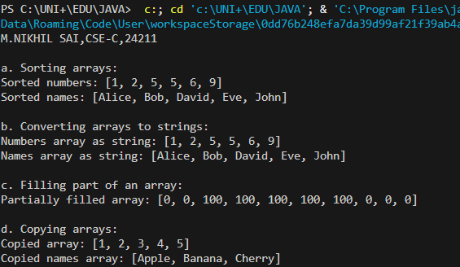
NEGATIVE CASE:
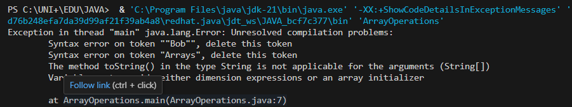
ERROR TABLE:
S.No | Reason for error | rectification
2. | .sort(words); | Arrays.sort(words);

IMPORTANT POINTS:
- The code demonstrates sorting arrays to both integers and strings using Arrays.sort().
- It converts arrays to string representations with Arrays.toString()
- It uses Arrays.fill() to fill entire arrays or parts of arrays with specifiec values.
- The code copies arrays using Arrays.copyOf() to create new arrays with the same elements.
4)AIM:
Implement a java program using the below Array List methods.
a. insert an element at particular index in the array list.
b. Modify an element in the array list.
c. Access an element from the array list.
d. Remove an element from the array list.
e. clear the elements from the array list.
CLASS DIAGRAM:
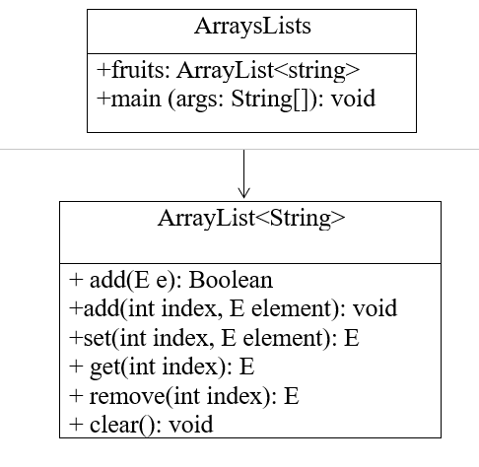
PROGRAM:
import java.util.ArrayList;

public class ArrayListDemo {
public static void main(String[] args) {
System.out.println("M.NIKHIL SAI,CSE-C,24211");
ArrayList<String> fruits = new ArrayList<>();
fruits.add("Apple");
fruits.add("Banana");
fruits.add("Orange");
System.out.println("Initial ArrayList: " + fruits);
fruits.add(1, "Mango");
System.out.println("\na. After inserting 'Mango' at index 1: " + fruits);
fruits.set(2, "Grapes");
System.out.println("\nb. After modifying index 2 to 'Grapes': " + fruits);
String element = fruits.get(0);
System.out.println("\nc. Element at index 0: " + element);
fruits.remove(3);
System.out.println("\nd. After removing element at index 3: " + fruits);
fruits.clear();
System.out.println("\ne. After clearing the ArrayList: " + fruits);
}
}
OUTPUT:
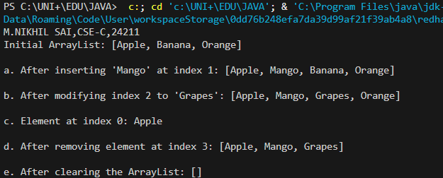
NEGATIVE CASE:
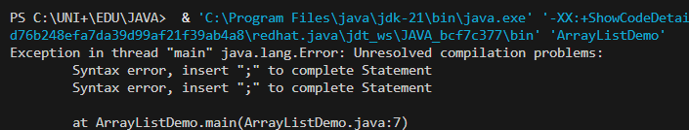
ERROR TABLE:
S.No | Reason for error | rectification
2. | ArrayList<String> fruits = new ArrayList | ArrayList<String> fruits = new ArrayList<String>();

IMPORTANT POINTS:
- Elements are inserted at specific positions using the add(index, element) method.
- The set(index, element) method is used to modify existing elements.
- Elements are accessed and removed using the get(index) and remove(index) methods respectively.
- The entire list can be cleared using the clear() method to remove all elements.

